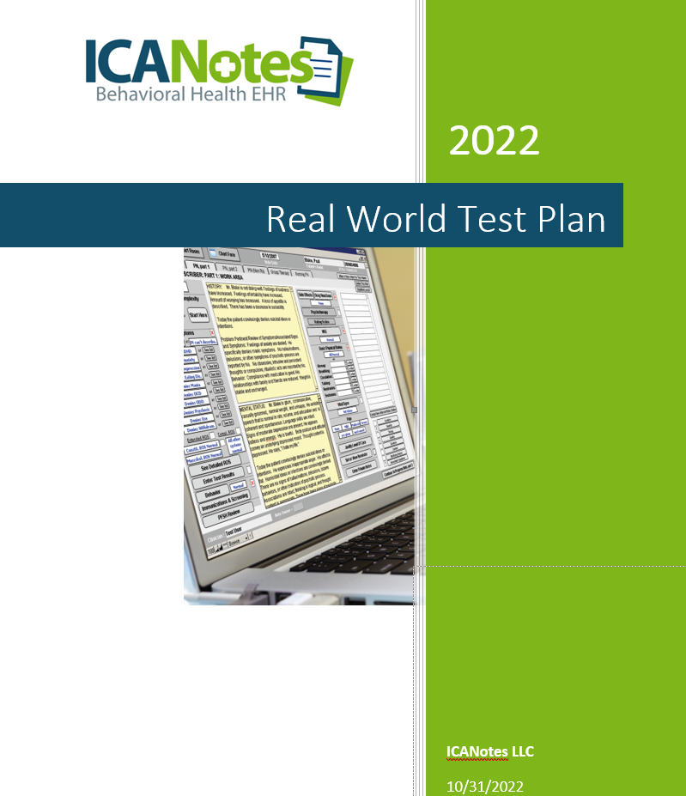
2021 Real World Plan11/15/2021
Real-World Test Plan | 10/31/2022
GENERAL INFORMATION
Plan Report ID Number: RWT Plan ICANotes - 10-31-2022
Developer Name: ICANotes, LLC
Product Name(s): ICANotes EHR/EMR for Behavioral Health
Version Number(s): 11.6, Edition 2015, Certification Date: 12/31/2018
Certified Health IT: 15.04.04.1637.ICAN.11.00.1.181231
Product List (CHPL) ID(s): 15.04.04.1637.ICAN.11.00.1.181231
Developer Real World Testing Page URL:
https://www.icanotes.com/wp-content/uploads/2021/11/RWTPlan-11-11-2021.pdf
JUSTIFICATION FOR REAL WORLD TESTING APPROACH
ICANotes is a medium-sized EHR founded in 1999 and designed by a psychiatrist to serve exclusively behavioral health providers. ICANotes serves those involved in behavioral health, including psychiatry, psychology, therapy, and addiction treatment. Currently certified for the 2015 Health Information Technology Edition, ICANotes uses a cloud-based solution. The majority of ICANotes customers provide outpatient services and receive referrals from other clinicians regularly.
It is ICANotes' belief that a single Real World Testing plan can address multiple certification criteria.
We will be utilizing real-time patient data and real-world production environments when implementing Real World Testing.
There might be a need to change our test methodology or approach based on what we found during our testing. During testing, this will only happen to accommodate unforeseen issues or problems that may arise. In these instances, a results report will document these types of changes, their reasons, and how intended outcomes were met more efficiently as a result.
Testing will take place via Go2Meeting software in the production environment using real-time patient data. Demographic information will be altered to ensure HIPAA privacy regulations are met. An agency will be selected to send and receive transitions of care. Testing will include the clinician or practice staff member, an ICANotes representative who interacts with the clinician, and an ICANotes observer who acts as recorder. Development staff will be on standby during the testing for assistance if needed. Measures will be tested will in a logical order to avoid unnecessary repetition and to minimize the clinician’s time.
ICANotes has been conducting real-world testing in 2022. We will submit the results of our testing by March 15, 2023.
The ICANotes team will adjust to our customers' workflows and needs during the testing process.

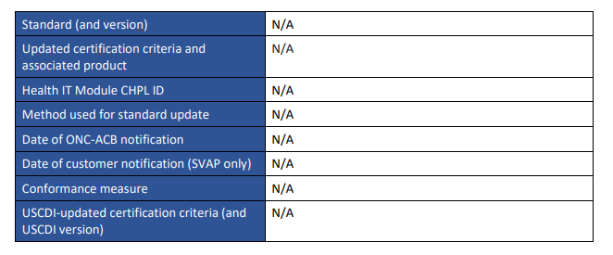

MEASURES USED IN OVERALL APPROACH
DESCRIPTION OF MEASUREMENT/METRIC
The Measure/Metrics and Descriptions for Measures 1-5 listed below will apply to multiple criteria simultaneously to demonstrate the functionality of these certified measures:
• § 170.315(b)(1) Transitions of Care (Receive)
• § 170.315(b)(2) Clinical Information Reconciliation and Incorporation
• § 170.315(c)(1) Clinical Quality Measures Record and Export
• § 170.315(b)(1) Transitions of Care (Send)
• § 170.315 (e) (1) View, Download and Transmit to 3rd Party
The Measure/Metrics and Descriptions for Measures 6 - 8 will apply to § 170.315(b)(6) Data export.
The Measure/Metrics and Descriptions for Measures 9 – 11 will be used to demonstrate the following criteria respectively:
• § 170.315 (g) (7) Application Access – Patient Selection
• § 170.315 (g) (8) Application Access Data Category Access
• § 170.315 (g) (9) Application Access – All Data Request

Measure 1:  Clinician logs into ICANotes and receives a CCDA from a external individual via Direct Protocol with no Tech Support and no errors. CCDA has demographic information adjusted so PHI is not visible. Successful receipt of CCDA is achieved and observed. The amount of time should be no more than 60 seconds. | Clinician begins a new patient encounter in ICANotes certified software with a patient referred by an external individual. With a Direct Address and unique Kno2 credentials, the clinician is able to have a seamless login and secure receipt of CCDA from the external individual using Direct Protocol (Surescripts is the underlying software that allows use of Direct Messaging). Common Clinical Data Set (CCDS) standard will be demonstrated in these transactions through screenshots collected. Log files are also captured. These will all show the successful receipt of the CCDA with all fields completed. This will meet § 170.315(b)(1) (Receive).

Measure 2:  The CCDA is validated, and Clinical Information Reconciliation is performed. No errors are  expected. The amount of time should be no more than 180 seconds. | After successful receipt of the CCDA, the clinician validates the CCDA within ICANotes. Clinical information reconciliation for medication, medication allergy, and current problem list is performed using ICANotes software. CCDS standard will be demonstrated in these transactions through screenshots collected. Log files demonstrate the reconciliation. This will meet § 170.315(b)(2).
Measure 3:  Documentation of Medications (CQM #68) is done without  assistance. The amount of time taken to document should be no more than 60  seconds. No errors are expected. | ICANotes clinician easily completes Documentation of Medications (CQM #68) within appropriate location in ICANotes software to meet 170.315(c)(1) by completing the appropriate fields in ICANotes software. The following day it will be reflected in the numerator and denominator of this MIPS CQM measure.
Measure 4:  Updated CCDA is sent back to external individual. Successful sending of CCDA is achieved and observed. The amount of time to send the document should be no more than 60  seconds. | Clinician sends updated CCDA with minimal delay back to external individual via Direct Protocol. Updated CCDA is also sent to the patient portal. Confirmation of sent CCDA is captured along with log files. This will meet § 170.315(b)(1) (Send).
Measure 5:  Access via patient portal -  Observation of the View,  Download & Transmit functions is performed. This will demonstrate the portal as a key tool for the clinician to share the patient’s most current health information with the patient. The amount of time should be no more than 3 minutes total for 3 tasks and there should be no errors. | Real-time patient data will be adjusted to protect PHI before Measure 5 is completed. Office staff member is allowed access to patient portal to view patient CCDA and download the CCDA without assistance. Transmission of patient data will be sent to another office staff member. This will meet § 170.315(e)(1).

Measure 6:  Practice staff member successfully exports data file on demand. | Authorized office practice staff member will perform an export of CCDA data from the production server in real-time (on demand) with a specific start and end date immediately. This will be done without delay and sent to a specific file location decided by the staff member. This will be accomplished efficiently and with no error and the file will be inspected when received to ensure it is the file requested. Real world data will be used but demographic information will be changed to protect PHI. This measure allows the capture of report data selected by and on demand without assistance from development staff. The ability to independently create reports is vital to office practices and integral to a certified EHR. ICANotes staff will verify the reports have been created successfully with requested data through verbal acknowledgements screenshots. This will meet part of § 170.315(b)(6).
Measure 7:  Practice staff member successfully exports a file at a delayed time − with a specific start and end date. | Authorized office practice staff member will perform an export of CCDA data in the future − 5 minutes from now ─ from the production server with a scheduled specific start and end date − such as November 1 - November 2, 2021. This will be accomplished efficiently and with no error and the file will be inspected when received to ensure it is the file requested. This measure allows the staff member to select a time in the future without assistance from development staff. The ability to independently create reports is vital to office practices and integral to a certified EHR. ICANotes staff will verify the reports have been created successfully and sent to a specific file location with requested data through verbal acknowledgements and screenshots. This will meet another component of § 170.315(b)(6).
Measure 8:  Practice staff member sets an export for a delayed time during hours after the practice is closed and is able to run successfully. | Authorized office practice staff member sets up a specific data export to run after the practice is closed. This measure allows the capture of report data selected by and on demand without assistance from development staff. The ability to independently create reports is vital to office practices and integral to a certified EHR. ICANotes staff will verify the reports have been created successfully with requested data and sent to specific location with screenshots that capture the activity. This will meet the final component of § 170.315(b)(6).
Measure 9:  Provide staff member with API documentation. | Staff member uses a third-party application to communicate with ICANotes. Practice staff member acts as an authorized person (patient) and obtains a userKey and userSecret. A Patient ID is created which assures the privacy and security of the patient. This will meet § 170.315(g)(7).
Measure 10: | Using the Patient ID captured in Measure 9, the staff member demonstrates that the API allows the return compliant with the CCDS

A staff member will be able to use the API to view patient data for a specific date and time range. | standard from a specific date and time range. Tester verifies that the API routine can respond to a request for patient data for a specific date, and that the patient data returned is accurate and without omission and equivalent to the health IT developer’s documentation for the same data. This will meet § 170.315(g)(8).
Measure 11:  Staff member demonstrates the ability, through the use of the token, to receive the entirety of a patient CCDA for a specific time and date with all data categories. | The return of the data is confirmed to be the patient earlier selected and data is returned successfully and without delay. This will meet § 170.315(g)(9).
ASSOCIATED CERTIFICATION CRITERIA
List certification criteria associated with the measure and if updated to the 2015 Edition Cures Update criteria.
Measurement/Metric | Associated Certification Criteria
Measure 1* | § 170.315(b)(1) Transitions of Care (Receive)
Measure 2* | § 170.315(b)(2) Clinical Information Reconciliation and Incorporation
Measure 3* | § 170.315(c)(1) Clinical Quality Measures Record and Export
Measure 4* | § 170.315(b)(1) Transitions of Care (Send)
Measure 5* | § 170.315(e)(1) View, Download and Transmit to 3rd party
Measures 6 - 8 | § 170.315(b)(6) Data Export
Measure 9 | § 170.315(g)(7) Application Access – Patient Selection
Measure 10 | § 170.315(g)(8) Application Access Data Category Request
Measure 11 | § 170.315(g)(9) Application Access – All Data Request

*Measures 1 through 5 will be completed in one session.

JUSTIFICATION FOR SELECTED MEASUREMENT/METRIC
Measurement/Metric | Justification | Relied Upon Software
Measure 1:  Clinician logs into ICANotes and receives a CCDA from via an external individual viaDirect Protocol with  no Tech Support and no errors. CCDA has demographic  information adjusted so PHI is | The test plan will demonstrate the functionality of this measure. The ability to receive a CCDA without developer assistance is integral to the exchange of data and interoperability | Sure Scripts Messaging

not visible. Successful receipt of CCDA is achieved and observed. The amount of time should be no more than 60 seconds. | and inherent in a certified EHR. CCDA will use CCDS standard.
Measure 2:  The CCDA is validated and Clinical Information Reconciliation is performed. No errors are  expected. The amount of time should be no more than 180 seconds | A prescribing clinician will perform clinical information reconciliation for medication, medication allergy and the current problem list effectively without developer assistance. As a result, a revised CCDA using CCDS standard will be created which can then be shared with the referring clinician and be sent to the patient portal for patient access. The ability to do this as part of the test plan will show how clinicians can complete this task efficiently and without error. The most current information will be available to both clinicians and the patient as required by a certified EHR.
Measure 3:  Documentation of Medications (CQM #68) is done without assistance. The amount of time should be no more than 60 seconds. No errors are expected. | Regular documentation of  medications is a vital tool for clinical notes and a Clinical Quality Measure. By completing this task, the clinician or designated representative  performs an essential task required at each visit.
Measure 4:  Updated CCDA is sent back to external individual. Successful sending of CCDA is achieved and observed. The amount of time of time to send the document should be no more than 60 seconds. | The test plan will demonstrate the functionality of this measure. The ability to send a CCDA without developer assistance is integral to the exchange of data and interoperability inherent in a certified EHR.
Measure 5:  Access via patient portal ─  Observation of the View,  Download & Transmit functions is performed. This will  demonstrate the portal as a key tool for the clinician to share the | The patient portal is vital to all patients. Patients will be able to login at any time and view their most current information as well as share it with any other clinicians they might choose to visit. This allows the

patient’s most current health information with the patient. The amount of time should be no more than 3 minutes total for 3 tasks and there should be no errors. | exchange of information by the patients themselves which is key to giving them control of their health information. This is an essential part of certified EHR technology.
Measure 6:  Practice staff member is  observed successfully exporting data file on demand. | Exporting data consistent with the CCDS standard on demand is an essential requirement for a clinical practice with a certified EHR. Office staff need the capability of doing this immediately and successfully without developer assistance.
Measure 7:  Practice staff member is able to successfully export a file at a delayed time ─ with a specific start and end date. | Exporting data consistent with the CCDS standard at a relative time is a requirement for a clinical practice with a certified EHR. Office staff need the capability of doing this  successfully without developer assistance.
Measure 8:  Practice staff member is able to delay a file export to a time after the practice is closed and have it run successfully. | Exporting a specific report with large amount of data consistent with the CCDS standard after hours is an essential requirement for a clinical practice with a certified EHR. Office staff need the capability of doing this successfully without developer assistance. The certified EHR requires this capability to avoid placing undue load on the technology during regular business hours.
Measure 9:  Provide staff member with API documentation. | Demonstrate that providers and their patients can exchange or access health information through the use of a third-party application and with adherence to HIPAA privacy  regulations. This measure will show how the patient authentication component works using the API to ensure the correct patient has been selected, which is vital to the  exchange of data and interoperability in a certified EHR.

Measurement/Metric | Justification
Measure 10:  A staff member will use the API to view patient data for a specific date and time range. | The test plan will show the ability, through the use of the API, to isolate this same patient’s data for a specific date and time range, a key  requirement to identify specific data requested. The staff member will be able to do this without difficulty and in a straightforward manner.
Measure 11:  Staff member demonstrates the ability, through the use of the token, to receive the entirety of a patient CCDA for a specific time and date with all data categories. | A staff member will be able to retrieve the identified patient’s entire CCDA for a specific time and date range. The ability to do this as part of the test plan will show how this can be completed efficiently and without error. This enables the staff and patients to retrieve information through the API as required by a certified EHR.

CARE SETTING(S)
Care Setting | Justification
Outpatient Behavioral  Health Care Practices with 1-5 prescribing clinicians | The test plan will demonstrate the following using clinicians from the care setting of 1-5 prescribing clinicians, the ICANotes target audience:  Clinicians will receive CCDAs from a referring provider via Direct protocol. Surescripts, a CHPL certified product # 15.02.02.2391.A046.01.00.1.171109, is a third party used by ICANotes to provide the underlying structure for transporting CCDA using Direct Messaging. Next the clinician will conduct clinical information reconciliation for medication, medication allergy, and current problem list within ICANotes software. Documentation of Medications is an important Clinical Quality Measure available for use in the MIPS program and done through specific steps taken in the ICANotes software. The CCDS standard will be demonstrated in these transactions through screenshots collected.  Access via portal (View/Download/Transmit) (e1) is used by ICANotes providers to communicate with patients − a key requirement in a certified EHR. All required functions are demonstrated: view, download and transmit to third party. The office person will demonstrate view, download and transmit

9
Real-World Test Plan | 10/31/2022
Care Setting | Justification
with another staff member who has portal access. Real-time patient data will be altered before portal access is completed.
The ability to complete all measures successfully with these practices will be displayed through the completion of the testing and the results demonstrated. These will show how ICANotes is providing optimal service.
 | Successful data exports in real time, relative time and specific data export done after business hours display the ability of the staff member to perform these tasks using the reporting capabilities of the certified EHR.
 | The ability to use an API with an EHR allows clinicians using a certified EHR to successfully share data with other practices and with their patients directly. An API is a critical healthcare technology component.

EXPECTED OUTCOMES
Expected outcomes will include the following data points:
• Total number of events tested
• Number of passed (i.e. successful) events
• Number of failed events
• Success rate expressed in percentage (successes / total number of events)

As detailed in this plan under the “Schedule of Key Milestones” section, each measure/metric will be tested at least once per quarter with our clinician RWT groups to ensure the expected outcomes are reliably attained.

Measurement/Metric | Expected Outcomes
§ 170.315(b)(2) Clinical Information Reconciliation and Incorporation | The receiving clinician will be able to validate the CCDA consistent with the CCDS standard, perform reconciliation successfully for medication, medication allergy and problem list at any time without delay and create an updated CCDA as required to demonstrate EHR exchange of information and interoperability.
170.315(c)(1) Clinical  Quality Measures Record and Export | Documentation of current medications (CQM #68) will be completed in the ICANotes software without error, delay or developer assistance during each patient visit. This will then be reflected in the numerator and denominator of the MIPS CQM measure calculation.
§ 170.315(b)(1) Transitions of Care (Send) | The clinician will send the updated CCDA, consistent with the CCDS standard back to the an external individual successfully, without delay or developer assistance. This demonstrates the ability of the EHR to meet the Transitions of Care Send option, a key component of interoperability of a certified EHR.
§ 170.315(e)(1) View,  Download and Transmit to 3rd party | Office personnel will demonstrate the patient portal can be accessed without delay and reflect correct patient information in an accessible format for viewing, downloading and transmitting to another individual or institution. This allows the exchange of information by the patients themselves which is key to giving them control of their health information. This is an essential part of interoperability and certified EHR technology.
§ 170.315(b)(6) Data Export | Office personnel will perform data exports, consistent with the CCDS standard successfully without developer assistance. Data export capabilities are essential to the clinical practice’s day to day functionality and necessarily included in the EHR certification.
§ 170.315(g)(7) Application Access – Patient Selection | Staff member will be able to authenticate and verify a patient for use with the API without developer assistance. The expected time to complete the measure is 1 to 2 minutes, which will be compared with the actual time. This is an essential first component of the use of an API, key to a certified EHR.
§ 170.315(g)(8) Application Access – Data Category Request | Staff member will successfully request CCDA data for a specific date and time range without developer assistance and within 1 to 2 minutes. The data will be compared to the actual patient’s data for accuracy of data to reveal no errors.
§ 170.315(g)(9) Application Access – All Data Request | Entirety of CCDA for specific patient, for a specific time and date range, will be retrieved successfully and in a timely manner without developer assistance. Expected time to accomplish this task is 2-3 minutes.

SCHEDULE OF KEY MILESTONES
Key Milestone | Care Setting | Date/Timeframe
Identify the user practices that will participate in the test plan. | Ambulatory Setting, Behavioral Health | December 2021  (completed)

Confirm that the Real World Test Plan participants are able to log in successfully to their accounts prior to beginning the testing. | Ambulatory Setting, Behavioral Health | January 2022  (completed)
Perform testing. Collect data and review | Ambulatory Setting, Behavioral Health | Quarterly  (ongoing)
Conduct preliminary Data Analysis by software tools such as event log viewer, Filemaker itself to query the database, and SQL for other queries as needed. Make adjustments if needed. | Ambulatory Setting, Behavioral Health | Quarterly  (ongoing)
Real World Test analysis and generation of the report | Ambulatory Setting, Behavioral Health | January 2023
Submit Real World Test Report to ACB before deadline | Ambulatory Setting, Behavioral Health | February 2023

ATTESTATION
This Real World Test Plan is complete with all required elements, including measures that address all certification criteria and care settings. All information in this plan is up to date and fully addresses the health IT developer’s Real World Testing requirements.
Authorized Representative Name: Randy Holl
Authorized Representative Email: randy@icanotes.com
Authorized Representative Phone: 443-241-1944
Authorized Representative Signature:

Date: October 31, 2022

